Pocasset Prep 2019
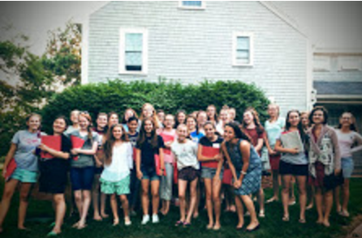

“If I could do it again, I would in a heartbeat.”

“I really liked the service day. I loved being able to bring

joy to others.”
“[I liked] making so many new friends and having fun
wherever we went.”

WHAT | A week of phone-free, fun, and formative activities with other rising freshmen to help develop skills and tools to ease the transition into high school - and for the rest of life! Our goal is to help the girls who attend Pocasset to flourish and grow into women who can be transformative leaders.
WHERE | Pocasset Prep is located at Arnold Hall Conference Center, mid-way between Boston and Cape Cod: 1 Randall St, Pembroke, MA 02358
WHEN | Sat. July 6 at 2:00 pm until Wed. July 10 at 2:00 pm
FACILITIES | We will stay in the Court House and Cottage buildings at the Arnold Hall Conference Center. The Court House has an attractive living room, chapel, and single or triple bedrooms with a total capacity of 24 participants and 4 staff. The 130-acre property has a basketball court, tennis courts, a large playing field, and a pond.
COST | $450.00. A $50 deposit is due after acceptance.  Unfortunately, there is no financial aid available for this program.
ACTIVITIES | - Classes on topics including friendship, time management, and more. These classes offer insights and practical applications to help participants grow and become agents of change in high school and beyond  - Sports and team building activities, including an excursion bicycling on Martha’s Vineyard  - Service outing: participants are challenged to get outside of themselves to serve others and to make practical resolutions to continue serving once they return home  - Mentoring: Each participant has a mentor to help them go deeper in the seminar topics and set personal goals  - Daily Mass and classes in Catholic doctrine are a part of the program. The Sacrament of Reconciliation will be available for those who desire it. The spiritual formation at Arnold Hall is entrusted to Opus Dei (www.opusdei.org), a personal Prelature of the Catholic Church.
APPLY | Parents: complete parent form here: https://goo.gl/forms/1xjFtVU3tXAb46Nj1  Students: complete student form here: https://goo.gl/forms/FcctMt3ZohbQRUPg2  Applications are due by February 15; applicants will be notified in early March.

Questions about the application process or program? Email CedarWoodHS@gmail.com

